**TOUCH SCREEN BASED HOME AUTOMATION SYSTEM**

**ABSTRACT**

The main objective of this project is to develop a home automation system with a touch screen based control panel.

As technology is advancing so houses are also getting smarter. Modern houses are gradually shifting from conventional switches to centralized control system, involving touch screen switches. Presently, conventional wall switches located in different parts of the house makes it difficult for the user to go near them to operate. Even more it becomes more difficult for the elderly or physically handicapped people to do so. Remote controlled home automation system provides a simpler solution with touch screen technology. Touch screen control panels are also designed for commercial, industrial and medical systems.

In order to achieve this, a touch panel is interfaced to the microcontroller on transmitter side which sends ON/OFF commands to the receiver where loads are connected. By touching the specified portion on the touch screen panel, the loads can be turned ON/OFF remotely through wireless technology. The microcontroller used here is of PIC family. The loads are interfaced to the microcontroller using opto-isolators and triacs.

Further the project can be enhanced by using GSM modem interfaced to the control unit. Using GSM modem, the user can control home appliances by sending an SMS. Advantage of using this technology is that there is not range limitation when compared to RF technology.

.

**SOFTWARE REQUIREMENTS:**

HI-TECH PICC Tool suite

Languages: Embedded C or Assembly

**HARDWARE REQUIREMENTS:**

PIC series microcontroller, Transformer, touch panel, opto-isolator, Triacs, RF module, Regulators, Crystal, Diodes, Resistors, Capacitors, Encoder, Decoder, Lamps.

**BLOCK DIAGRAM**

**TRANSMITTER**

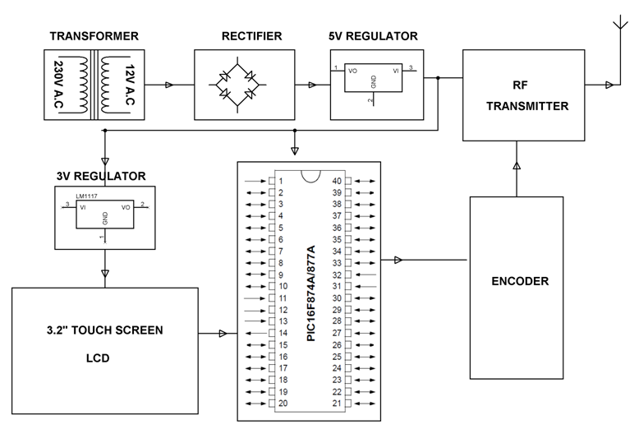

**RECEIVER**

